|  |  |
| --- | --- |
| Name |  |
| Phone |  |
| Email |  |
| Postal Address |  |
| City/Postcode |  |



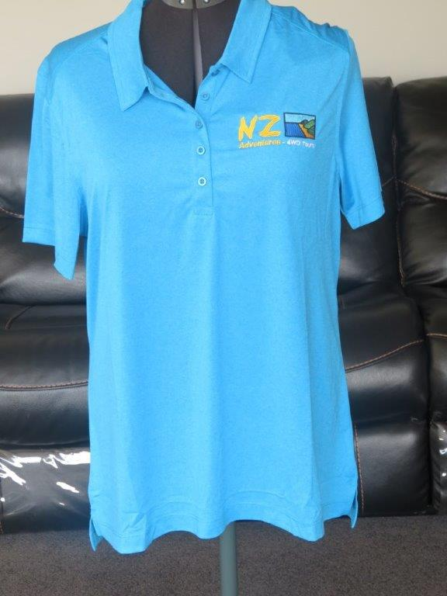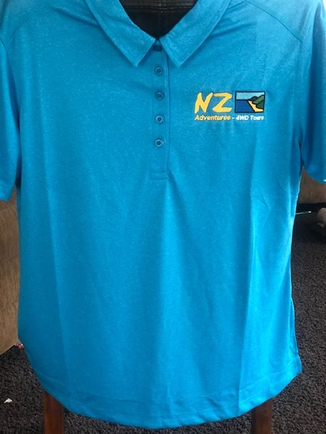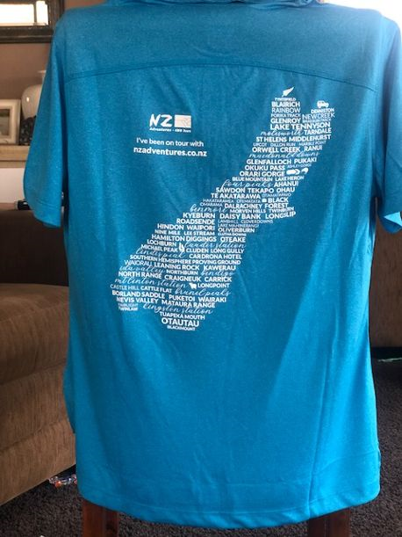

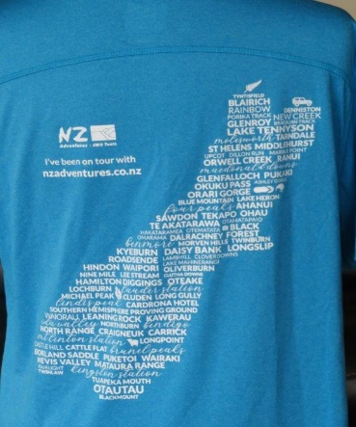

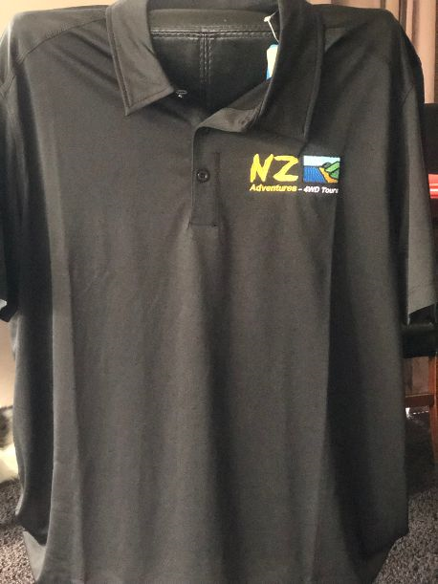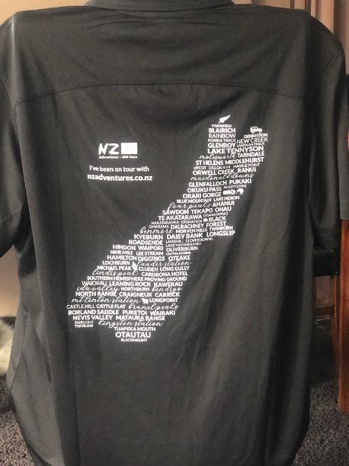

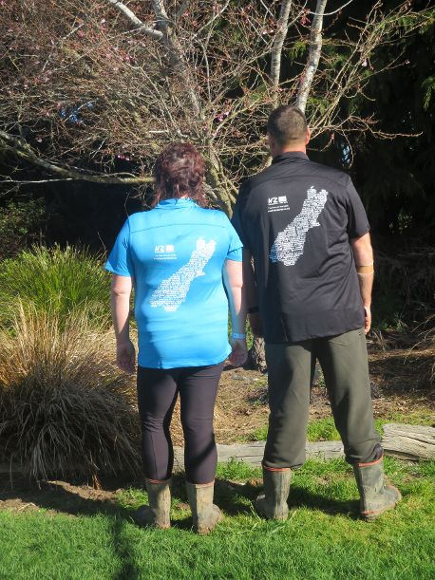

|  |  |  |  |  |  |  |
| --- | --- | --- | --- | --- | --- | --- |
| Description | *Ladies*  Sizes *Mens* | | | Qty | Price  (Postage Included) | Amount |
| **10/12/14/16/1820/22** | | **S/M/L/XL/2XL/3XL** |
| Ladies Blue T-Shirt |  |  | |  | $60.00 |  |
| Ladies Black T-Shirt |  |  | |  | $60.00 |  |
| Mens T-Shirt (Black Only) |  |  | |  | $60.00 |  |
|  |  |  | |  | Total |  |